Unit III

Terms:
Metabolism Second law of thermodynamics
First law of thermodynamics Enzyme
Reduction (reduced) Oxidation (oxidized)
Cellular respiration Light dependent reaction
Light independent reaction Chloroplast
Thylakoid Stroma
Chlorophyll Mitochondria
Mitochondrial matrix Mitochondrial Cristae
Chemiosmosis Electron transport system
Water Carbon dioxide
Glucose Pyruvate
Glyceraldehyde 3-phosphate (G3P) Ribulose bisphosphate (RUBP)
Oxaloacetate Carotenoid (carotene)
ATP ADP
NADP NAD
FAD FADH
NADPH NADH
Oxidative phosphorylation anabolic
catabolic endergonic
exergonic Metabolic pathway
cytoplasm Photosynthesis
Oxygen glyceraldehydes 3-phosphate (G3P)
Know the definition of energy and the two laws of thermodynamics and their relationship
to entropy
Know the function of enzymes and their specificity and how they act.
Remember the chemical reactions: hydrolysis and dehydration synthesis (condensation)
Know the definition of metabolism, anabolic, catabolic, endergonic, exergonic and which
of the two chemical reactions is involved in each.
Know the formula (balanced) of photosynthesis and cellular (aerobic) respiration.
Know the vitamins given in class in relation to the metabolic pathways
covered in this unit.
Know the structure of the chloroplast and the mitochondria and know the exact location
in these organelles of the pathways covered in this unit.
Be able to recognize oxidation-reduction reactions within the pathways covered.
Know what an ETS is and its function.
Be able to define chemiosmotic theory of ATP production (chemiosmosis)
Know the function of ATP syntetase (ATP synthase).

Photosynthesis: know the photosynthetic pigment, chloroplast structure, location of the
light dependent pathway (reactions) and light independent pathway (reactions)
Be able to follow the electron from the chlorophyll molecule through the two
pathways to glucose.
Know the electrons temporary storage molecule and its final resting place.
Know the source of the oxygen made during photosynthesis
Know how many of the beginning molecules are required to make one O₂
Know the reactants and products of each pathway
Know the beginning and ending intermediate for the light independent pathway

Cellular respiration: know the structure of the mitochondria and be able to identify the
most specific location of the Krebs Cycle and oxidative phosphorylation.
Know the location of glycolysis
Know the entering reactants and products of each of the three pathways of
cellular respiration and how many of each enter and how many of the
end products are produced.
Know the total number of ATPs is profited from cellular respiration
Know how many ATPs are produced and profited in each of the three pathways
Knot the beginning and ending intermediate of the Krebs cycle

1. Process by which the cell acquires uses and stores energy.

2. The energy available to the universe is constant.

3. Reactions that break apart macromolecules releasing nutrients and energy to be used by the organism.

4. Chemical reactions do not create nor destroy energy

5. This molecule orients its substrate to promote a chemical reaction.

6. Process involved in the elimination of waste produced during the utilization of energy.

7. Energy of one form is converted to a less concentrated form whenever energy is transformed or transferred.

8. A series of chemical reactions mediated by enzymes that can be biosynthetic or degradative.

9. When the energy from the sun excites an electron away from chlorophyll, the chlorophyll is said to be

10. A pathway that is exergonic, degradative and releases energy.

11. This molecule can change shape during a reaction but returns to its original shape when the reaction is over.

12. The vitamin riboflavin is the precursor for which coenzyme?

13. Adding an electron with a hydrogen ion to NADP is what type of reaction.

14. The most specific location of chlorophyll in a plant.

15. The conversion of light energy to chemical energy.

16. This molecule is specific to its substrate, temperature and pH.

17. The oxygen produced during photosynthesis originated from which reactant.

18. Where is the most specific location of the light independent reaction?

19. The end product of photosynthesis is

20. The internal membrane system of the chloroplast is called.

21. Where is the most specific location of the light dependent reaction?

22. This pigment is green because it reflects the wavelengths of light between 450nm and 550nm.

23. Concentration differences of hydrogen ions and electrochemical gradients across a membrane in association with ATP production is part of what process.

24. This process transfers electrons, in a stepwise fashion, form one membrane protein to another.

25. This is considered an accessory pigment which is not capable of photosynthesis but can assist the process.

26. The movement of hydrogen ions through ATP-synthetase will produce which molecule?

27. Where is the final resting place for the excited electrons in photosynthesis?

28. This pigment is absolutely necessary for photosynthesis to take place.

29. During photosynthesis two molecules of must be split to produce one molecule of

30. The flow of hydrogen ions from the inner lumen of the thylakoid to the stoma through ATP-synthetase is part of which process.

31. This pigment is orange because it reflects the wavelengths of light between 600nm and 695nm.

32. Electron transport system is part of this process.

33. The carbon dioxide acceptor in the light independent reaction.

34. The beginning and ending intermediate of the light independent reaction.

35. 6CO₂ + 12H₂O + light energy ---------> C₆H₁₂O₆ + 6O₂ + 6H₂O

36. C₆H₁₂O₆ + 6O₂ + 6H₂O ---------> 6CO₂ + 12H₂O + ATP

37. The entering reactant of glycolysis is what molecule?

38. Where is the most specific location of glycolysis?

39. What is the end product of glycolysis?

40. What molecule is reduced during glycolysis?

41. Where does the Krebs cycle take place?

42. What is the name of the molecule that enters into the mitochondria and bonds with the beginning and ending intermediate of the Krebs cycle?

43. Where is the most specific location of oxidative phosphorylation?

44. What is the name of the beginning and ending intermediate of the Krebs cycle?

45. What molecule is reduced in both glycolysis and Krebs cycle?

46. Which metabolic pathway of cellular respiration produces the largest number of ATP?

47. What atom is the final electron acceptor of cellular respiration?

PHOTOSYNTHESIS

1. Explain what happens at P680 and how chlorophyll maintains its chemical structure throughout the day.

2. On what molecule is the electron temporarily stored between the light dependent pathway and the light independent pathway?

3. Where is the final resting place for that electron?

4. How is the electron moved through the thylakoid membrane?

5. By what process is ATP produced from ADP + P_{i}, during the light dependent reaction?

CELLULAR RESPIRATION

Glycolysis:
1. For one glucose that enters glycolysis how many of the following will be used?
ATP, NAD, ADP

2. For one glucose that enters glycolysis how many of the following will be produced?
G3P, NADH, ATP, pyruvate

3. How many total ATP molecules are produced during glycolysis?

4. What is the ATP profit from glycolysis?

Krebs Cycle + oxidation of pyruvate:
5. For one pyruvate that enters the Krebs cycle how many of the following will be used?
NAD, FAD, ADP,

6. For one pyruvate that enters the Krebs cycle how many of the following will be produced?
NADH, FADH₂, ATP, CO₂

7. For one glucose how many of the following will be used during the Krebs cycle?
NAD, FAD, ADP,

8. For one glucose how many of the following will be produced during the Krebs cycle?
NADH, FADH₂, ATP, CO₂

9. For each glucose how many ATP molecules will be produced from the Krebs cycle?

Oxidative phosphorylation (electron transport phosphorylation):
10. Where do the NADH and FADH₂ that enters Oxidative Phosphorylation come from?

11. How many ATP molecules will be produced form one NADH during Oxidative Phosphorylation?

12. How many ATP molecules will be produced form one FADH₂ during Oxidative Phosphorylation?

13. How many total ATP molecules will be produced form Oxidative Phosphorylation?

14. How many total ATP molecules are profited form Cellular Respiration?

Photosynthesis

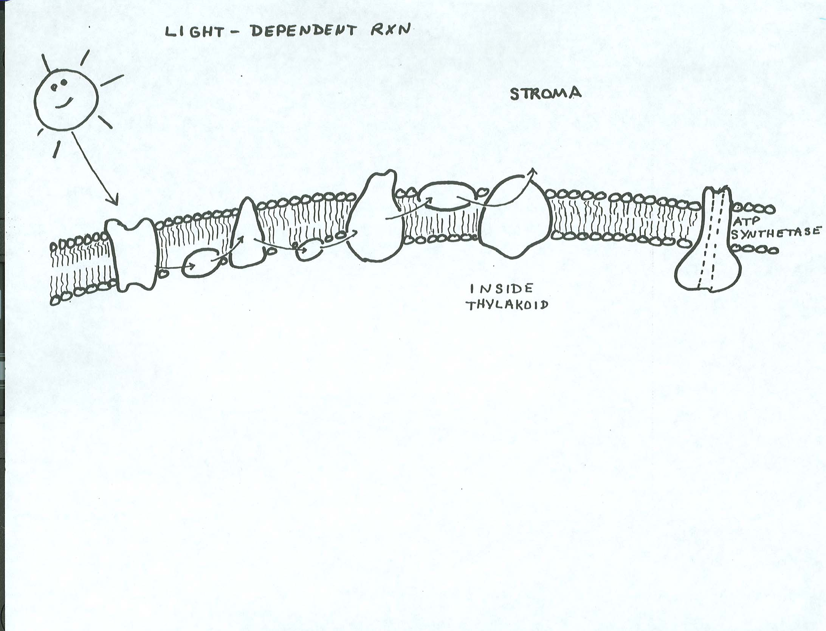

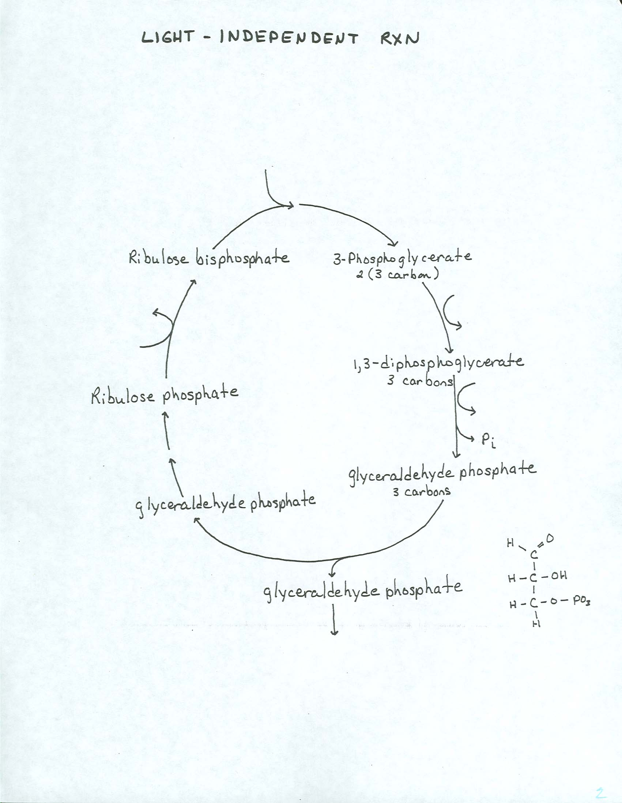

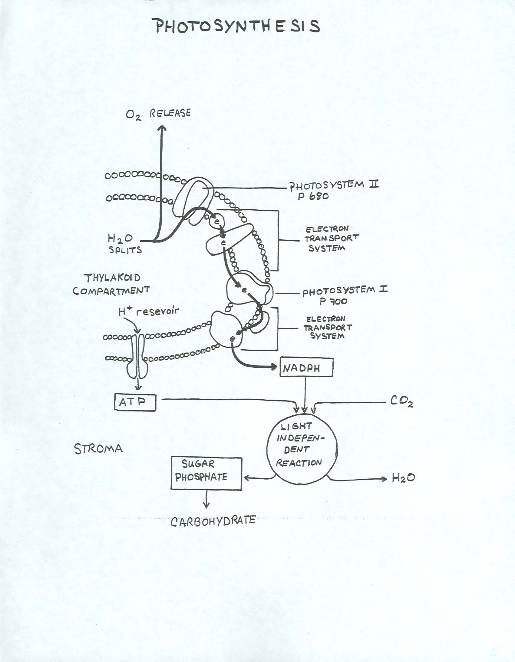

Cellular respiration



